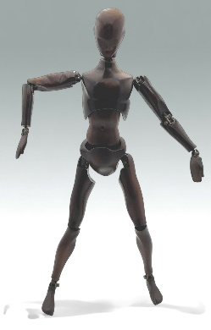
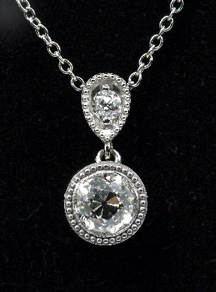
BURCHARD GALLERIES
1030} Atsco Oscar Bakelite Artist's Model
1060) Calatrava Style Bead Set Diamond Necklace
JULY AUCTIONS
Saturday July 20, 2024 Discovery
Sunday July 21, 2024 Premier
Estate Antiques Fine Art & Jewelry
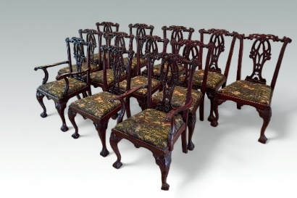
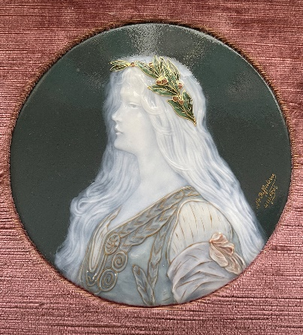
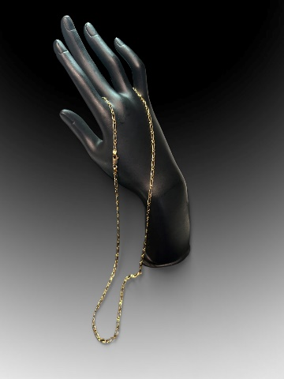
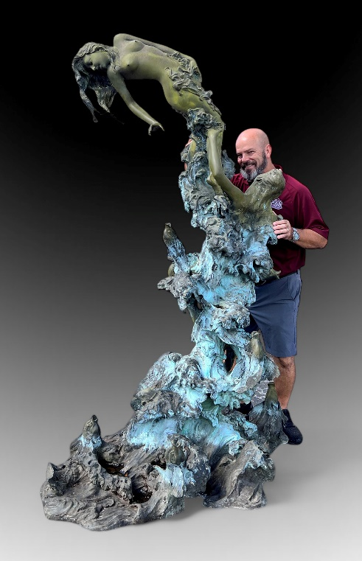
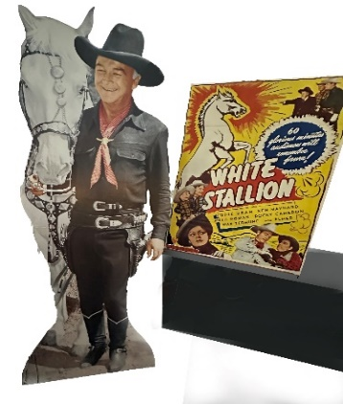
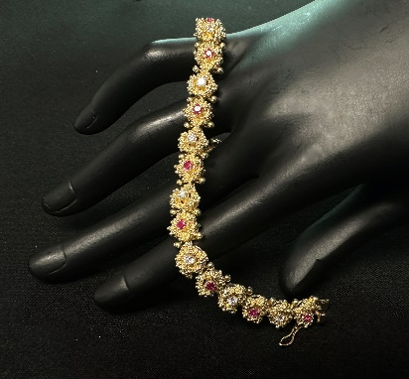
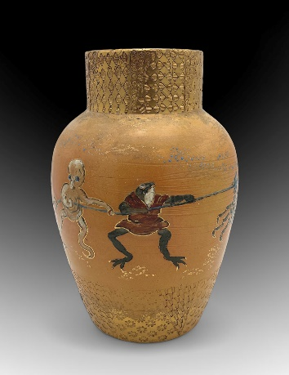
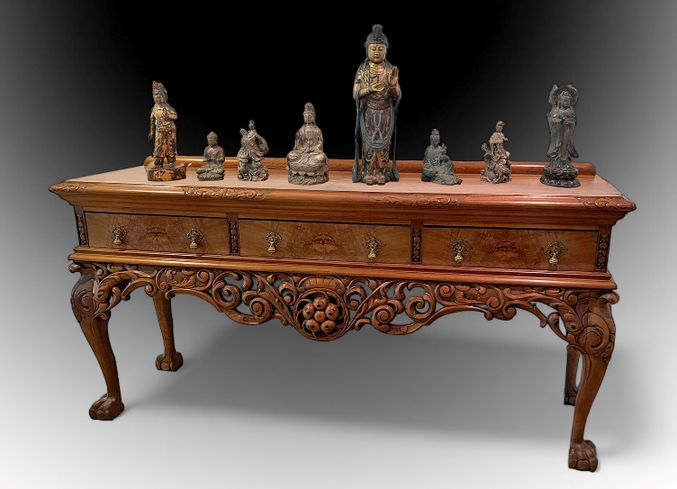
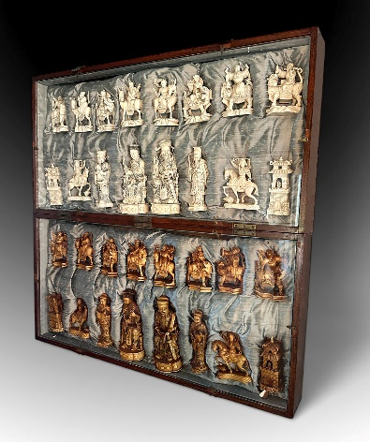

Premium Furnishings from a Mega-Million Dollar Naples Mansion, Theodore Alexander and Lexington Leather Living Room Suites, Formal Mahogany, Museum Quality Listed Artist Works, Sevres Palace Urns, Estate Jewelry, and many more most unusual treasures!
Set of 12 Richly Carved Chippendale Style Chairs
1042} Limoges Pat Sur Pate
1085) Vintage 18K Gold Figaro Chain 23 inches
1005) Bronze Fountain in the manner of Angelo Basso. Illegibly signed, not Basso
Western Movie Lobby Displays
1065) 18K Burma Ruby & Diamond Bracelet
1025} Maria Longworth Nichols Rookwood Vase
Carved Asian Altar Table and Many Buddhas inc. Bronze
1050) Very Large Carved Ivory Chess Set
3130) Kurt Larisch Paintings
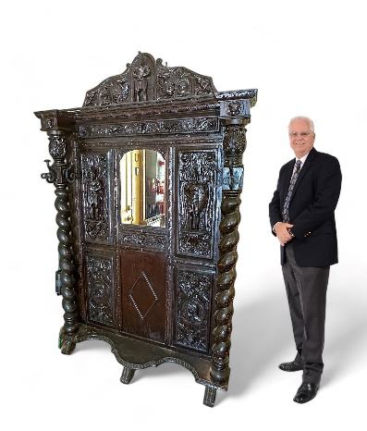
Consignments Welcome BurchardGalleries.com mail@BurchardGalleries.com 727-821-1167 AU 322 AB 169

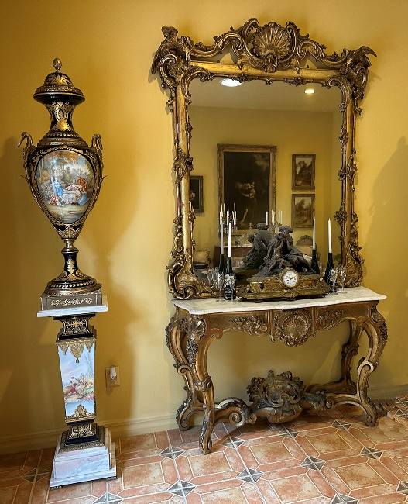

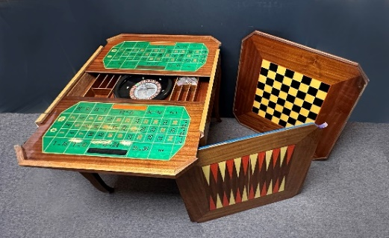
7 Pc Gaming Table Italian Marquetry & Parquetry Inlaid

